**Medical Imaging : Brain Tumor Detection from MRI using CNN and Transfer Learning**

*A project report submitted to ICT Academy of Kerala*

*in partial fulfillment of the requirements*

*for the certification of*

**CERTIFIED SPECIALIST**

**IN**

**MACHINE LEARNING AND ARTIFICIAL INTELLIGENCE**

submitted by

**Gazal Vahab**

**Keerthi M**

**Sreekumar V**

**Sanitha E S**



**ICT ACADEMY OF KERALA**

**THIRUVANANTHAPURAM, KERALA, INDIA**

**May 2024**

**List of Figures**

1. **Figure 1: Original MRI Image and Cropped Image**

Description: Comparison between an original MRI image and its cropped version.

2**. Figure 2: Augmented Images Generated by the save_augmented_images Function**

Description: Example of augmented images produced by the save_augmented_images

function using Keras ImageDataGenerator, showing variations in the input images.

3. **Figure 3: Architecture of the CNN Model**

Description: Detailed structure of the Convolutional Neural Network (CNN) model used for brain tumor detection.

4. **Figure 4: VGG16 Model Architecture**

Description: Structure of the VGG16 model utilized for transfer learning in brain tumor detection.

5. **Figure 5: ResNet50 Model Architecture**

Description: Structure of the ResNet50 model used for deep learning in brain tumor detection.

6. **Figure 6: MobileNet Model Architecture**

Description: MobileNet designed for efficient inference on mobile and embedded devices with limited computational resources.

7. **Figure 7: DenseNet121 Model Architecture**

Description: Dense Convolutional Network, is a deep learning architecture known for its dense connectivity patterns between layers.

8. **Figure 8: Comparative Performance of All Models**

9. **Figure 9 : User Interface for Brain Tumor Prediction.**

10. **Figure 10 : User Interface of Brain Tumor Image Upload and Prediction Result.**

**List of Abbreviations**

AI - Artificial Intelligence

CNN - Convolutional Neural Network

RGB - Red, Green, Blue (color channels)

RNN - Recurrent Neural Network

**Table of Contents**

**Introduction**

* 1.1 Background
* 1.2 Objectives
* 1.3 Scope

**Literature Review**

* 2.1 Overview of Image Augmentation
* 2.2 Techniques and Methods
* 2.3 Applications

**Methodology**

* 3.1 Data Collection
* 3.2 Data Preprocessing
* 3.3 Image Augmentation Techniques

**Implementation**

* 4.1 System Design
* 4.2 Image Augmentation
  + 4.2.1 ImageDataGenerator
  + 4.2.2 Image Augmentation
    - 4.2.2.1 The save_augmented_images Function
  + 4.2.3 Image Augmentation Parameters
  + 4.2.4 Example Augmented Images

**Results and Discussion**

* 5.1 Augmentation Outcomes
* 5.2 Analysis of Results
* 5.3 Comparison with Original Data

**Conclusion**

* 6.1 Summary of Findings
* 6.2 Future Work
* 6.3 Final Remarks

**References**

**Abstract**

**Medical Imaging: Brain Tumor Detection Using CNN and Transfer Learning**

One of the most promising areas of health innovation is the application of artificial intelligence (AI), particularly in medical imaging. AI in medical imaging leverages advanced algorithms to analyze medical images, enhance diagnostics, and improve precision and efficiency in healthcare. These algorithms can be trained to detect abnormalities or subtle changes in medical images that may be challenging for human eyes, leading to more accurate and efficient diagnosis and treatment of various conditions.

In this study, we focus on detecting brain tumors from MRI images using Convolutional Neural Networks (CNN) and Transfer Learning. Our dataset[7] comprises images of both normal and cancerous brains. To address the limited size of the dataset, we employ data augmentation techniques using Keras ImageDataGenerator to increase its diversity.

We utilize CNNs and various transfer learning methods, including VGG, ResNet, and MobileNet, to build models capable of detecting cancerous cells in MRI images. Furthermore, we perform hyperparameter tuning to optimize model performance.

This comparative analysis aims to evaluate the effectiveness of CNN and different transfer learning approaches in accurately detecting brain tumors from medical images.

**Problem Definition**

**1.1 Overview**

The integration of artificial intelligence (AI) in healthcare, particularly in medical imaging, represents a significant advancement in the field. AI algorithms are capable of analyzing medical images with high precision, identifying abnormalities and subtle changes that may be missed by human eyes. This leads to improved diagnostic accuracy and efficiency. Our study centers on the application of Convolutional Neural Networks (CNN) and Transfer Learning for the detection of brain tumors in MRI images. By leveraging these advanced techniques, we aim to enhance the accuracy of brain tumor detection, thereby contributing to better patient outcomes.

**1.2 Problem Statement**

Brain tumors pose a significant challenge in medical diagnostics due to their complexity and the subtle nature of their presentation in MRI images. Traditional diagnostic methods are time-consuming and heavily reliant on the expertise of radiologists, which can lead to variability in diagnosis. The limited size of available medical image datasets further complicates the development of robust AI models for tumor detection. This study aims to develop an AI-based solution using CNNs and transfer learning to accurately detect brain tumors from MRI images. By employing data augmentation techniques to overcome dataset limitations and leveraging advanced models such as VGG, ResNet, DenseNet and MobileNet, this study seeks to enhance diagnostic accuracy and efficiency. The objective of this study is to perform a comparative analysis of these models to determine the most effective approach for brain tumor detection, thereby contributing to improved healthcare outcomes.

**Introduction**

Medical imaging is a cornerstone of modern healthcare, providing critical insights into a wide range of medical conditions. Recent advancements in artificial intelligence (AI) have revolutionized medical imaging, enabling the development of sophisticated algorithms that can analyze images with high precision. AI techniques, particularly Convolutional Neural Networks (CNNs), have shown great promise in detecting abnormalities that may not be easily discernible by human eyes, leading to more accurate diagnoses and improved patient outcomes.

Despite these advancements, brain tumor detection remains a challenging task due to the complex and subtle nature of tumors in MRI images. Traditional diagnostic methods are often time-consuming and reliant on the expertise of radiologists, which can result in variability and potential delays in diagnosis. The integration of AI in this domain has the potential to significantly enhance diagnostic accuracy and efficiency, thereby improving clinical decision-making and patient care.

The primary objective of this project is to develop and evaluate CNN and Transfer Learning models for the accurate detection of brain tumors in MRI images. By employing data augmentation techniques and leveraging advanced CNN architectures such as VGG, ResNet, DenseNet and MobileNet, we aim to overcome the limitations posed by the limited size of available datasets and improve the performance of our models. Additionally, we will perform hyperparameter tuning to optimize the models and conduct a comparative analysis to determine the most effective approach for brain tumor detection.

This project report is organized as follows: Section 3 provides a literature survey, discussing key studies and findings in this area. Section 4 presents the experimental results of our study. Finally, Section 5 concludes the report and suggests directions for future research.

**Literature Survey**

Langs, Georg in 2024[1] conducted a seminar and reported that the increasing role of artificial intelligence (AI) in medicine, driven by advanced machine learning methods and abundant clinical data. AI algorithms are enhancing clinical care by improving image reconstruction, cancer detection, and individual risk prediction, thus supporting treatment decisions and patient management. Successful integration into clinical practice depends on technological feasibility, workflow integration, and immediate benefits. Research is focusing on combining imaging data with other modalities like genomics and linking large-scale observations to biological processes. AI's impact on imaging and precision medicine stems from both the adaptation of established techniques and the collaborative development of new technologies, advancing diagnosis and care.

Lu, Shao Lun, Xiao, Fu Ren, Cheng in 2021[2] discusses a study evaluating the impact of artificial intelligence (AI) assistance on stereotactic radiosurgery (SRS) for brain tumors. Accurate tumor contouring, which is critical for SRS, is traditionally time-consuming and varies between practitioners. The study involved nine medical professionals who contoured brain tumor cases with and without AI assistance using an advanced auto-contouring algorithm. The results showed that AI assistance significantly improved inter-reader agreement and contouring accuracy, especially for less experienced physicians, and increased lesion detection sensitivity. Additionally, AI assistance led to a 30.8% time-saving overall. Experienced SRS specialists benefited more from time savings, while less-experienced clinicians saw notable improvements in accuracy. The study concludes that deep learning neural networks can enhance both accuracy and efficiency in clinical workflows for brain tumor SRS.

Khushi Jha, Awadhesh Kumar in 2017[3] studied the evolution of deep learning techniques in medical imaging, with a focus on detecting brain tumors through MRI scans. It covers a wide range of datasets used in tumor detection and details various deep-learning methods, particularly emphasizing Convolutional Neural Networks (CNNs) and Recurrent Neural Networks (RNNs). The review analyzes trends in model performance from previous studies and their potential impact on healthcare. It highlights challenges like insufficient labeled data for training robust models and discusses preprocessing techniques such as data augmentation, normalization, and standardization. Performance metrics, including sensitivity, specificity, accuracy, recall, AUC-ROC, and F1 score, are compared to provide a clearer understanding of model efficiency. The review offers a comprehensive overview of current trends in brain tumor detection and future directions, such as the use of multimodal data and the growing importance of explainable AI in medical imaging. It serves as a valuable resource for researchers and practitioners aiming to advance deep learning-based diagnostic tools in clinical settings.

Mohammad Ihsan Fazal, Muhammed Ebrahim Patel in 2018[4] said that the transformative role of artificial intelligence (AI) in the early detection and accurate diagnosis of neurological disorders. AI significantly enhances medical imaging analysis, enabling precise identification of neurological anomalies through MRI, CT scans, and X-rays. This facilitates early intervention and improved patient outcomes for conditions such as Alzheimer's, Parkinson's, multiple sclerosis, and brain tumors. Additionally, AI utilizes large datasets, including clinical records, genetic information, and biosensor data, to predict and assess individual susceptibility to these disorders, promoting personalized medicine and proactive healthcare. The paper also discusses ethical considerations, highlighting the importance of transparent algorithms, data privacy, and unbiased AI systems to maintain patient trust. The evolving field of AI in neuroscience fosters collaboration between AI experts and neuroscientists, aiming to advance early detection, targeted treatments, and overall quality of life for patients. The paper underscores AI's pivotal role in revolutionizing the detection and management of neurological disorders.

Aleid, Adham, Alhussaini, Khalid in 2023[5] said that the transformative role of artificial intelligence (AI) in the early detection and accurate diagnosis of neurological disorders. AI significantly enhances medical imaging analysis, enabling precise identification of neurological anomalies through MRI, CT scans, and X-rays. This facilitates early intervention and improved patient outcomes for conditions such as Alzheimer's, Parkinson's, multiple sclerosis, and brain tumors. Additionally, AI utilizes large datasets, including clinical records, genetic information, and biosensor data, to predict and assess individual susceptibility to these disorders, promoting personalized medicine and proactive healthcare. The paper also discusses ethical considerations, highlighting the importance of transparent algorithms, data privacy, and unbiased AI systems to maintain patient trust. The evolving field of AI in neuroscience fosters collaboration between AI experts and neuroscientists, aiming to advance early detection, targeted treatments, and overall quality of life for patients. The paper underscores AI's pivotal role in revolutionizing the detection and management of neurological disorders.

**3. Methodology**

3.1 Dataset

The dataset[7] used for this work contains MRI images, 155 of which are tumorous and 98 of which are normal.

3.2. Data Preprocessing

3.2.1 Cropping Images:

· The crop_img function detects the extreme points of the largest contour in an image and crops the image to that rectangular region.

· The function ensures the image is in RGB format, applies Gaussian blur, thresholds the image, and then performs erosions and dilations to reduce noise.

· Contours are found, and the largest one is used to determine the extreme points for cropping.

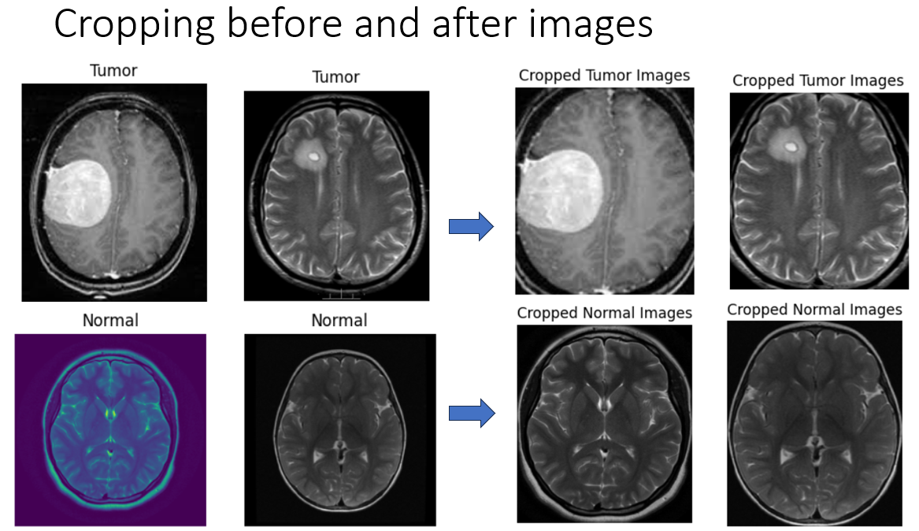

3.2.2. Image Augmentation:

·The save_augmented_images function generates and saves augmented versions of the input images using the Keras ImageDataGenerator.

· It loads each image, converts it to an array, and reshapes it for augmentation.

·Augmented images are saved to the specified directory with a given prefix and format.

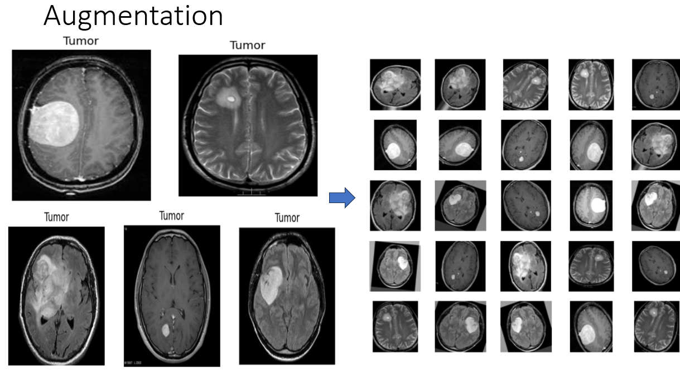

3.2.3. Loading and Processing Images:

· The load_images_and_labels function loads original and augmented images, applies cropping using crop_img, and resizes them to 224x224 pixels.

· It iterates through original images and augmented images directories, loading, cropping, and resizing each image.

· The images and their corresponding labels are stored in lists X and y.

3.2.4. Standardizing Images:

· The array of images X is standardized by dividing by 255.0 to normalize the pixel values to the range [0, 1].

3.3 Model Building

3.3.1 Convolutional Neural Network (CNN)

Convolutional Neural Networks (CNNs) are a class of deep learning models specifically designed to process and analyze visual data. CNNs utilize a series of convolutional layers to automatically and adaptively learn spatial hierarchies of features from input images. These layers apply convolution operations using filters (kernels) to detect patterns such as edges, textures, and objects. Typically, convolutional layers are followed by pooling layers that reduce the spatial dimensions, helping to achieve translation invariance and reduce computational complexity. CNNs are widely used in image classification, object detection, and other computer vision tasks due to their ability to capture local dependencies and maintain spatial hierarchies in images.

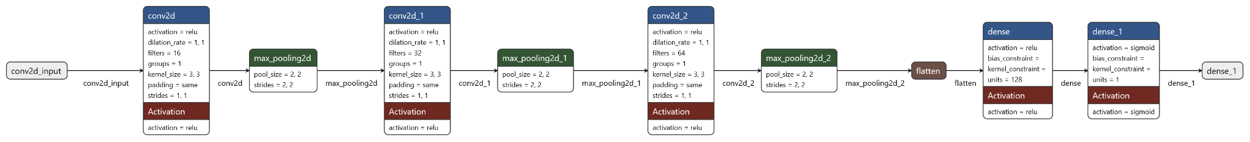

The given model is a Sequential CNN designed for binary classification tasks. It begins with a Conv2D layer with 16 filters, a kernel size of 3x3, and ReLU activation, followed by a MaxPooling2D layer to reduce the spatial dimensions. This pattern is repeated with increasing filter sizes (32 and 64) in subsequent Conv2D layers, each followed by MaxPooling2D layers. These convolutional layers help the model learn increasingly complex features from the input images. After the convolutional and pooling layers, the model is flattened into a one-dimensional vector and passed through a dense layer with 128 units and ReLU activation to learn high-level features. The final layer is a dense layer with a single unit and sigmoid activation for binary classification. The model is compiled with the Adam optimizer and binary cross-entropy loss, and it includes accuracy as a performance metric.

3.3.2. Transfer Learning

Transfer learning is a machine learning technique where a pre-trained model, developed for a specific task, is reused as the starting point for a model on a different but related task. This approach leverages the knowledge gained from large datasets to enhance the performance of models on smaller, more specific datasets, significantly reducing training time and improving accuracy.

ImageNet is a large-scale visual database designed for use in visual object recognition research. It contains millions of labeled images across thousands of categories and serves as a benchmark for evaluating the performance of computer vision models. Models pre-trained on ImageNet have learned rich feature representations from this diverse and extensive dataset, making them highly effective for transfer learning in various computer vision applications.

3.3.3. VGG16

VGG16 is a convolutional neural network architecture that has gained popularity for its simplicity and effectiveness in image classification tasks. Developed by the Visual Geometry Group (VGG) at the University of Oxford, VGG16 is characterized by its uniform architecture, using 16 layers consisting of 13 convolutional layers followed by 3 fully connected layers. The model uses small 3x3 filters and a fixed-size kernel throughout its convolutional layers, which helps in capturing fine details in images while maintaining computational efficiency. VGG16 was trained on the ImageNet dataset and has achieved excellent performance, making it a popular choice for transfer learning applications.

Sequential Model with VGG16 Base

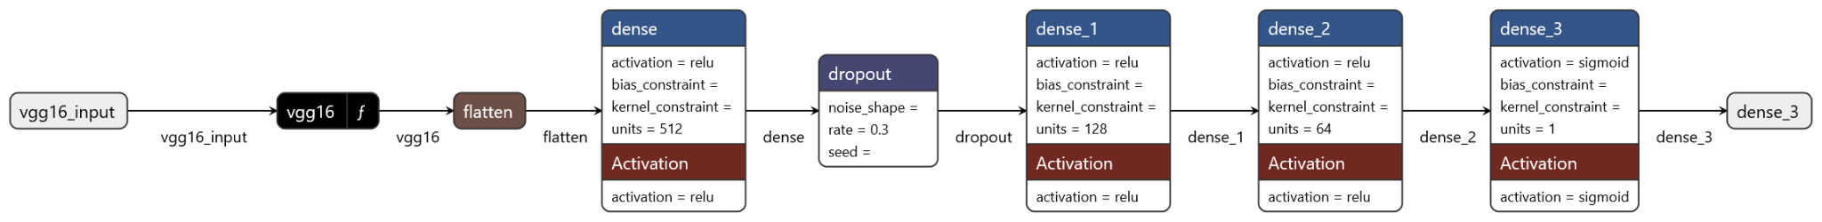

In this model, VGG16 is used as the base model, pre-trained on the ImageNet dataset with its top layers removed (include_top=False). The base model's layers are frozen to retain the learned features, preventing them from being updated during training. A new Sequential model is built on top of the VGG16 base, starting with a Flatten layer to convert the 3D feature maps to a 1D vector. This is followed by dense layers with 512, 128, and 64 units, respectively, each with ReLU activation, and a Dropout layer with a rate of 0.3 to prevent overfitting. The final layer is a dense layer with a single unit and sigmoid activation, suitable for binary classification. The model is compiled using the Adam optimizer and binary cross-entropy loss, with accuracy as the performance metric.

3.3.4. ResNet

ResNet, short for Residual Networks, is a highly successful deep learning architecture introduced by Microsoft in 2015. It addresses the vanishing gradient problem, which hampers the training of very deep neural networks, by using skip connections, or shortcuts, that allow gradients to bypass one or more layers. This innovation enables the construction of extremely deep networks, such as ResNet50, which contains 50 layers, by ensuring that the gradients can flow more effectively through the network during training. ResNet's design allows it to achieve remarkable performance on various computer vision tasks, including those in the ImageNet competition, where it set new benchmarks for accuracy.

Sequential Model with ResNet50 Base

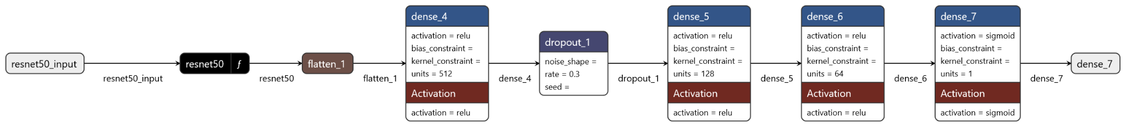

This model utilizes ResNet50 as its base, pre-trained on the ImageNet dataset with the top layers removed (include_top=False). The layers of the ResNet50 base are frozen to preserve the pre-trained features. A new Sequential model is constructed on top of this base, beginning with a Flatten layer to convert the output into a 1D vector. This is followed by dense layers with 512, 128, and 64 units, respectively, each activated by ReLU, and a Dropout layer with a rate of 0.3 to prevent overfitting. The final layer is a dense layer with a single unit and sigmoid activation, ideal for binary classification. The model is compiled with the Adam optimizer and binary cross-entropy loss, and it tracks accuracy as a performance metric.

3.3.5 MobileNet

MobileNet is a lightweight convolutional neural network architecture designed for efficient inference on mobile and embedded devices with limited computational resources. Developed by Google, MobileNet employs depthwise separable convolutions, which separate the standard convolution into two stages: a depthwise convolution and a pointwise convolution. This separation significantly reduces the number of parameters and computations required while maintaining competitive accuracy levels. MobileNet is known for its speed and compactness, making it well-suited for real-time applications on devices like smartphones, drones, and IoT devices. It has become a popular choice for tasks such as image classification, object detection, and image segmentation in resource-constrained environments.

Sequential Model with MobileNet Base



This model utilizes MobileNet as its base architecture, which is pre-trained on the ImageNet dataset and configured to exclude the top layers (`include_top=False`). The layers of MobileNet are then frozen to retain the learned features during training. A new Sequential model is constructed on top of MobileNet, starting with a Flatten layer to transform the output into a 1D vector. Following this, dense layers with 512, 128, and 64 units are added, each utilizing ReLU activation, along with a Dropout layer with a dropout rate of 0.3 to prevent overfitting. The final layer is a dense layer with a single unit and sigmoid activation, making it suitable for binary classification tasks. The model is compiled using the Adam optimizer with binary cross-entropy as the loss function and accuracy as the evaluation metric. This configuration allows the model to leverage the pre-trained MobileNet features while fine-tuning the top layers for the specific binary classification task at hand.

3.3.6. DenseNet

DenseNet, short for Dense Convolutional Network, is a deep learning architecture known for its dense connectivity patterns between layers. Unlike traditional architectures where each layer connects only to the subsequent layer, DenseNet connects each layer to every other layer in a feed-forward fashion. This dense connectivity facilitates feature reuse, gradient flow, and enhances model learning capabilities, leading to improved accuracy and parameter efficiency. DenseNet achieves this connectivity through densely connected blocks, where each layer receives inputs from all preceding layers and passes its own feature maps to all subsequent layers. This architecture has gained popularity for its ability to effectively handle vanishing gradients, promote feature propagation, and achieve state-of-the-art performance on various image classification tasks.

Sequential Model with DenseNet121 Base

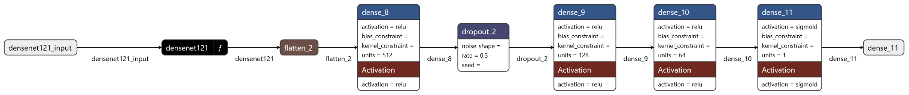

The model utilizes DenseNet121 as its base architecture, pre-trained on the ImageNet dataset and configured to exclude the top layers (`include_top=False`). The layers of DenseNet121 are then frozen to retain the learned features. A new Sequential model is built on top of DenseNet121, starting with a Flatten layer to convert the output into a 1D vector. Subsequently, dense layers with 512, 128, and 64 units are added, each using ReLU activation, along with a Dropout layer with a dropout rate of 0.3 to prevent overfitting. The final layer is a dense layer with a single unit and sigmoid activation, making it suitable for binary classification tasks. The model is compiled using the Adam optimizer with binary cross-entropy as the loss function and accuracy as the evaluation metric. This configuration leverages the powerful features of DenseNet121 while adapting the top layers for the specific binary classification task.

**Result**

Preprocessing Type : 1

In Preprocessing Type 1, the dataset undergoes comprehensive preprocessing steps to prepare it for analysis. This includes initial image processing such as converting grayscale images to RGB format if needed, applying Gaussian blur, thresholding, erosion, and dilation to reduce noise, and detecting contours to crop images based on extreme points. The dataset, consisting of 155+98 images before augmentation, undergoes these steps to enhance feature extraction and ensure data quality. This rigorous preprocessing approach aims to create a clean and standardized dataset suitable for training machine learning models effectively.

Preprocessing Type : 2

In Preprocessing Type 2, the focus is on data augmentation, resizing, and standardization to prepare the dataset for analysis. Augmentation techniques such as rotation, scaling, and flipping are applied to increase the diversity of the dataset and improve model generalization. Images are then resized to a standard size, typically 224x224 pixels, to ensure uniformity and compatibility with deep learning models. Finally, standardization is performed by scaling pixel values to a range of [0, 1] to facilitate model training and convergence. This streamlined preprocessing approach aims to augment data diversity, standardize image sizes, and normalize pixel values for effective model training and evaluation.

**Model Performance Comparison**

| **Preprocessing Steps** | **Aug+Crop+Resizing+Normalization** | | **Aug+Resizing+Normalization** | |
| --- | --- | --- | --- | --- |
| **Model** | **Test Loss** | **Accuracy** | **Test Loss** | **Accuracy** |
| **VGG16** | **0.3182** | **0.9258** | **0.1284** | **0.9457** |
| **ResNet** | **0.7198** | **0.4846** | **0.5426** | **0.7183** |
| **CNN** | **0.5911** | **0.8406** | **1.018** | **0.7907** |
| **MobileNet** | **0.479** | **0.9847** | **0.1949** | **0.9456** |
| **DenseNet** | **0.1433** | **0.9591** | **0.1214** | **0.964** |

Observations

Preprocessing Type 1

* MobileNet, offers lowest test loss and highest accuracy.
* ResNet, due to its high test loss and low accuracy.
* VGG16, CNN, and DenseNet show varying degrees of performance, with DenseNet being closer to MobileNet in terms of effectiveness.

Preprocessing Type 2

* VGG16, ResNet improves with just resizing and normalization, showing an increase in accuracy and a decrease in test loss
* CNN's performance drops indicating it might benefit from additional preprocessing steps
* MobileNet performs slightly worse than with the more extensive preprocessing but still shows high accuracy and low test loss
* DenseNet achieves the best results with resizing and normalization

**Web Application**

The web application is crafted to assess images submitted by users, determining whether they exhibit a tumor or not. Developed with Flask for the backend, Python for server-side processing, and HTML/CSS complemented by JavaScript for the frontend, the application boasts a user-friendly interface for image uploads. Upon uploading an image, the system employs a pre-trained deep learning model(MobileNet) to conduct the analysis and deliver a classification outcome. Users can swiftly receive feedback on the tumor presence in their uploaded images, showcasing the application's utility in medical image analysis.

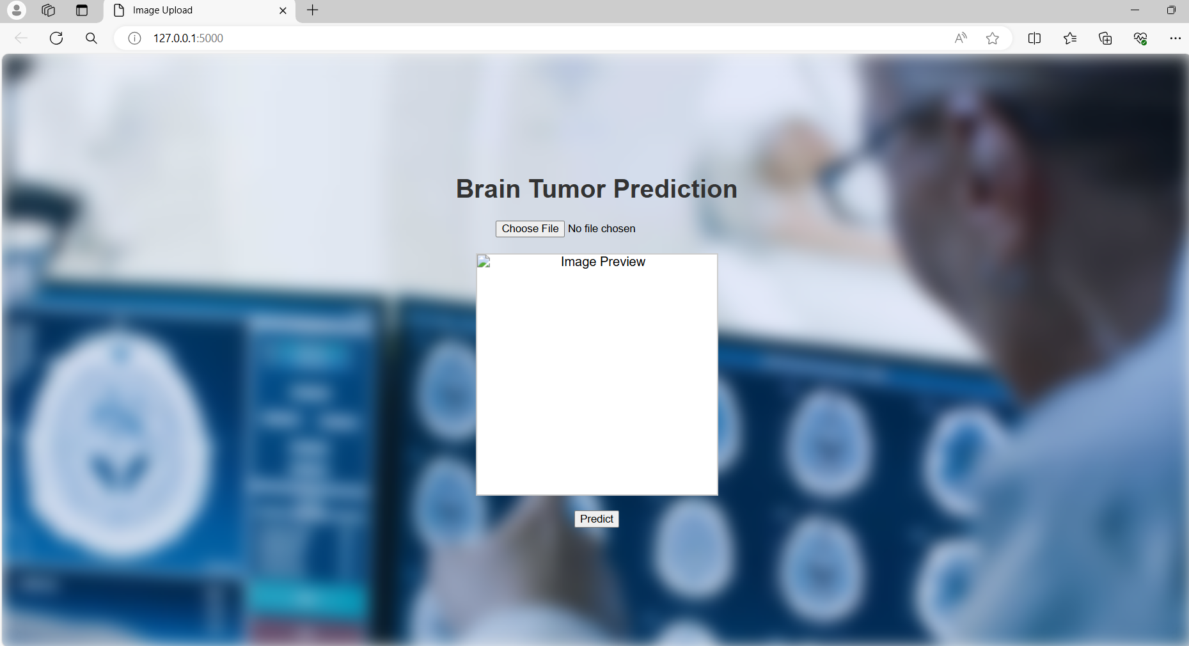

Fig: Home Page

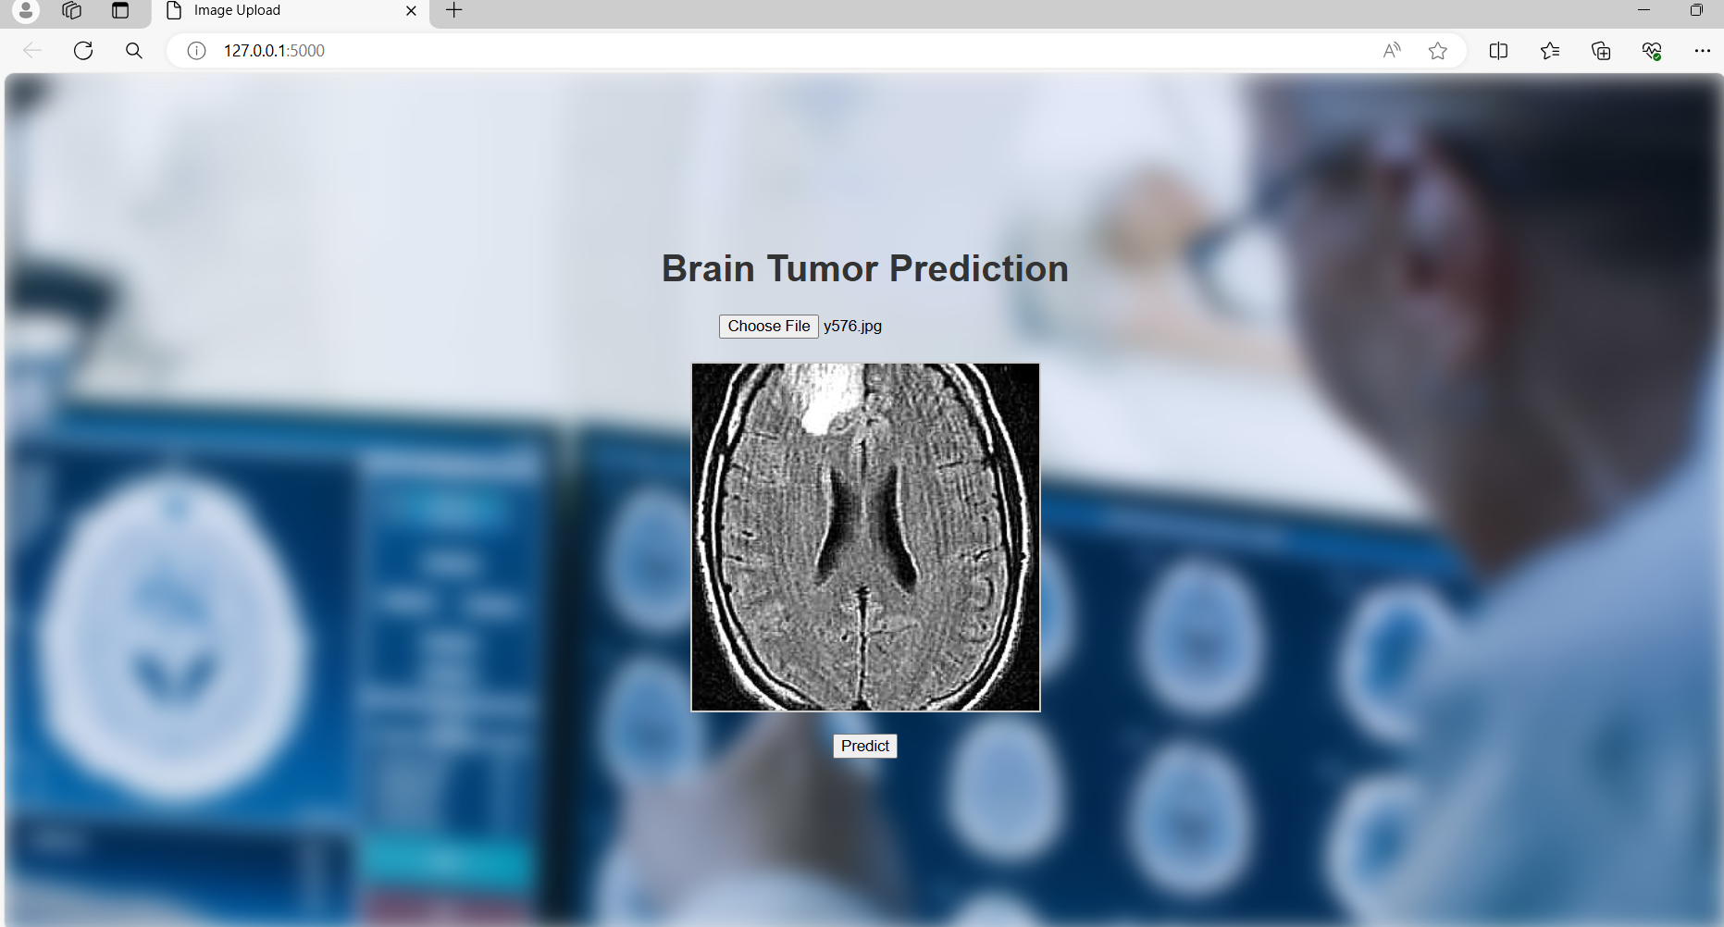

Fig: Image Upload

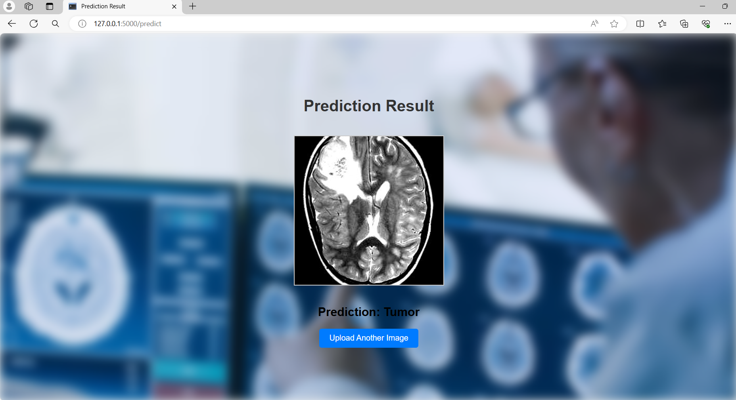

Fig: Prediction Result

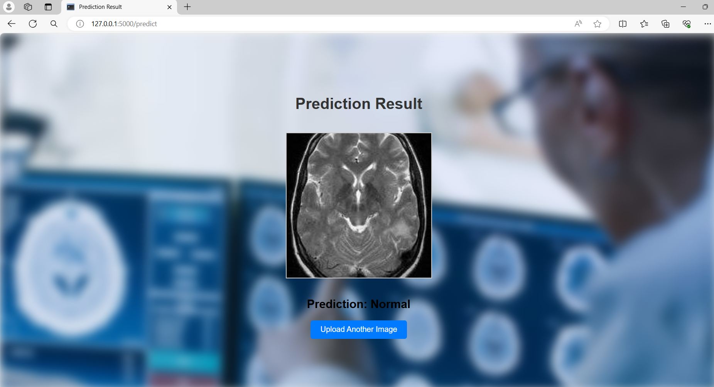

Fig: Prediction Result

**Conclusion**

The performance of various deep learning models was evaluated on a dataset that underwent different preprocessing steps. Two types of preprocessing were considered: one involving augmentation, cropping, resizing, and normalization, and the other involving only augmentation, resizing, and normalization.

Preprocessing Impact

The first preprocessing type, which included augmentation, cropping, resizing, and normalization, aimed to enhance feature extraction and data quality. In contrast, the second type focused on augmenting data diversity and standardizing image sizes and pixel values. The choice of preprocessing significantly influenced the model's performance.

Model Performance

The evaluation results demonstrated varying performances across different models. VGG16 showed competitive performance with a test loss of 0.3182 and an accuracy of 0.9258 in the first preprocessing type. ResNet exhibited a drop in performance with a test loss of 0.7198 and an accuracy of 0.4846. Conversely, MobileNet showcased robust results with a test loss of 0.479 and an impressive accuracy of 0.9847 in the first preprocessing type.

Website Implementation

The deep learning models were integrated into a web application developed using Flask for the backend, Python for server-side processing, and HTML/CSS along with JavaScript for the frontend. This web application allows users to upload images and receive instant feedback on whether the image is tumorous or not. The integration of these models into the web application ensures that users can benefit from advanced image analysis technology in a user-friendly interface.

**Conclusion**

In conclusion, the choice of preprocessing steps plays a crucial role in model performance. Models like VGG16 and MobileNet performed well with comprehensive preprocessing, while others like ResNet showed sensitivity to preprocessing variations. These findings emphasize the importance of tailored preprocessing strategies for optimizing deep learning model performance in image classification tasks. Further exploration and experimentation with preprocessing techniques can lead to improved model robustness and accuracy. Additionally, the successful implementation of these models in a web application demonstrates the practical applicability of deep learning in real-world medical image analysis, providing valuable tools for healthcare professionals and patients alike.

**References**

1. Langs, Georg (2024). Artificial intelligence in medical imaging is a tool for clinical routine and scientific discovery. [Artificial intelligence in medical imaging is a tool for clinical routine and scientific discovery - ScienceDirect](https://www.sciencedirect.com/science/article/abs/pii/S0049017223001634?via%3Dihub)
2. Lu, Shao Lun, Xiao, Fu Ren, Cheng (2021). Randomized multi-reader evaluation of automated detection and segmentation of brain tumors in stereotactic radiosurgery with deep neural networks. [Randomized multi-reader evaluation of automated detection and segmentation of brain tumors in stereotactic radiosurgery with deep neural networks | Neuro-Oncology | Oxford Academic (oup.com)](https://academic.oup.com/neuro-oncology/article/23/9/1560/6180141?login=false)
3. Khushi Jha, Awadhesh Kumar (2017). Role of Artificial Intelligence in Detecting Neurological Disorders. [Role of Artificial Intelligence in Detecting Neurological Disorders | International Research Journal on Advanced Engineering Hub (IRJAEH)](https://irjaeh.com/index.php/journal/article/view/30)
4. Mohammad Ihsan Fazal, Muhammed Ebrahim Patel (2018). The Past, Present and Future Role of Artificial Intelligence in Imaging. [The past, present and future role of artificial intelligence in imaging - ScienceDirect](https://www.sciencedirect.com/science/article/abs/pii/S0720048X18302250#preview-section-abstract)
5. Aleid, Adham, Alhussaini, Khalid (2023). Artificial Intelligence Approach for Early Detection of Brain Tumors Using MRI Images. [Applied Sciences | Free Full-Text | Artificial Intelligence Approach for Early Detection of Brain Tumors Using MRI Images (mdpi.com)](https://www.mdpi.com/2076-3417/13/6/3808)
6. <https://www.kaggle.com/datasets/navoneel/brain-mri-images-for-brain-tumor-detection>